1. Log into namebase.io

1. Use Credential file

1. BREAK (Understand if this is not doable but want to see if we can pauce and wait for the url?)
   1. Detect successful login
      1. Successful go to 4
      2. Unsuccessful pause
         1. Request Authorization URL in Command line
         2. Allow user to enter URL
         3. Open URL in Chrome
         4. Login again
         5. Proceed to step 4
2. Capture total number of Domains

1. Device total number of domains by 100
2. Go to Domain Manager
3. Domain Manager
   1. Your Domains
      1. There are 100 Domains per page, so total URL / 100 will tell you about how many pages you have\

* + 1. Capture Your Domains - <https://www.namebase.io/manage/owned?page=1> thru Domains / 100

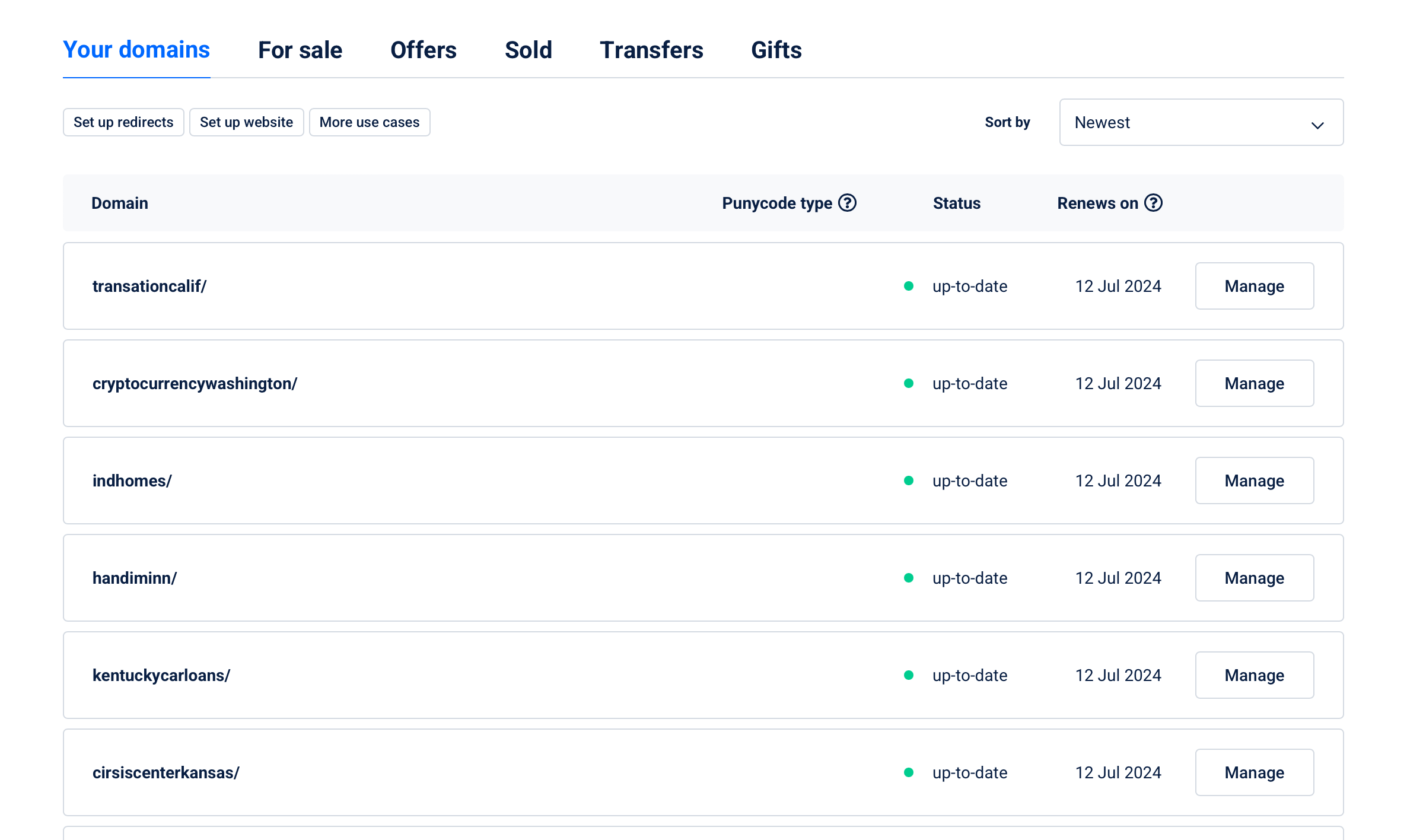

* + 1. Capture TLD Name
  1. For Sale
     1. Capture Domains and Information

* + - 1. Capture Domain
         1. Capture the TLD
         2. Open page TLD page

* + - * 1. Capture Current Sale Price

* + - * 1. Capture Highest Lockout

* 1. Sold Domain
     1. Go to Sold

* + 1. Capture Sold For price
    2. Open TLD Page
       1. Capture your highest lockout

Script 1 (Bid Bot)

Update to no bid on auctions that have already stated. (this will eliminate the popup issue and holding up HNS for actions I loss when I bid initially.